Master Idea List (more formatted version of everything we talked about)

- For Monday:
  - Mo and Brian chat about level design/art
  - Nat figure out how to share version control & setup google drive organization
  - Max (good luck with the car)

- Version Control
  - Unity devops version control
  - Free tier (3 seats & 5GB)
    - Seats will be Nat, Max, and Mo (Brian will work with Mo on this)
    - Will 5GB be enough? Should we request funding for the next tier up which would be
      - 4 - 15 seats: $7 / seat / month
      - Above 5 GB: $0.00019 / GB / hour
      - Example Scenario of a 5-person team
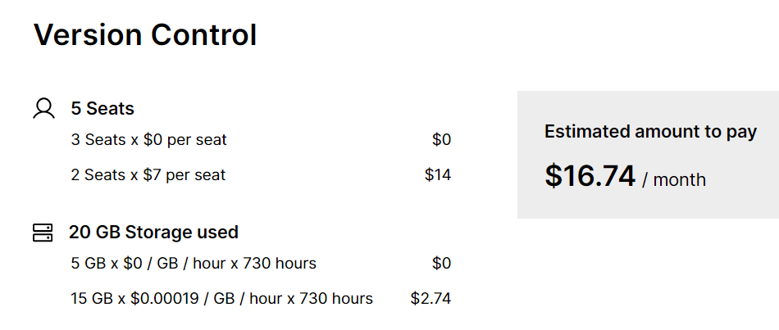

- Bugs/Things to Fix
  - Colliders between the player and the enemies
  - Clean up code (it should be fine for the most part, but there is obv still room for improvement)
  - Check for duplicate code
  - Make spider more prevalent in the scene

- Leaderboard
  - Leaderboard (keep track of time rather than by coins) - must collect all coins in level to have a valid time on the leaderboard?
  - Leaderboard consistency (saves every time you open and close the app)
    - Maybe we can have it so everyone that plays the game has access to the same leaderboard?
  - Keep track of coins and purchased items you have through every open of the app

- Art
  - Make more consistent throughout the menus and levels
  - Redo the spider art (it looks kinda washed out)
  - Redo enemy art to match the same style as the spider?
  - UI for lobby

- Lobby area for the shop
  - Interactable by using coins to purchase items or customizations
  - Unlock items by level progression and then buy them with coins
    - Ex: beat level 3 to unlock & price of 150 coins
  - Could be designed to be his loft
    - Desk with computer, sits down, and shop menu pops up
    - Trophy wall with achievements as the player progresses in the game
  - Things to buy with coins:
    - Spider skins
    - Different music
    - Web colors
    - Random prize/spin wheel?
    - When you die, you have the option of buying an extra life.

- Power Up Ideas:
  - Speed up
  - Slow down
  - Double jump
  - Invincibility
  - Plus health
  - Climb up the web
  - Be able to shoot your web at enemies

- New Mechanics:
  - Using your web to move stuff
  - Use the Web to hit target areas to open parts of the map.
    - Pull up/down levers
    - Breaking walls by pulling on wall mount (this could be in the shape of roots or flowers)
  - Climbing up specific walls to give spidery feeling

- Level Design ideas:
  - Levels will be in different cities
    - NYC → current
      - Statue of liberty, times square, empire state
    - Japan → pink/clean/nice
      - Cherry blossoms, bullet trains, kimonos
    - Rome → pillars
      - Colosseum, ancient buildings, pizza
    - Paris → catacombs
    - Island
    - Aliens → UFO theme

- Storyline:
  - Between levels, you have to travel. (Car, airplane, boat, etc.)
    - This leads to different cities and locations.
    - Incorporate crashes and what not to build on the timeline
  - Idea: After the last level, you find a hidden community of other spiders just like you (and surprise surprise its right back in new york). Sam might have traveled the world looking for a home, but it turns out that it was right under his nose all along…

- Lobby as you spawn in (things you should be able to do / access here)
  - Play -> story mode
  - Shop
  - Instructions
  - Credits
  - Global Leaderboard

